1. **Create a Docker Compose File**: Create a docker-compose.yml file:

version: '3'

services:

  apache:

    image: httpd

    ports:

      - "91:80"

    volumes:

      - ./apache_html:/usr/local/apache2/htdocs/

  nginx:

    image: nginx

    ports:

      - "92:80"

    volumes:

      - ./nginx_html:/usr/share/nginx/html/

1. **Create Content for Apache and NGINX**: Create directories for both Apache and NGINX content:

mkdir -p apache_html nginx_html

echo "<h1>Apache on Port 91</h1>" > apache_html/index.html

echo "<h1>NGINX on Port 92</h1>" > nginx_html/index.html



1. **Deploy the Services with Docker Compose**: Run the Docker Compose file:

docker-compose up -d

1. **Verify the Services**:
   * Visit http://<your_host_ip>:91 for Apache.
   * Visit http://<your_host_ip>:92 for NGINX.

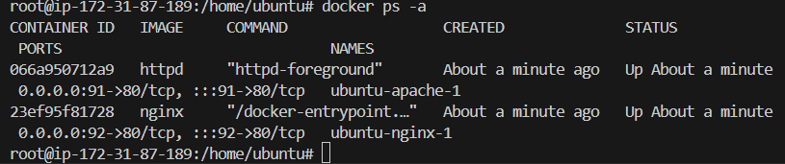





**Task 3: Initialize a Docker Swarm and Deploy Ubuntu Containers in an Overlay Network**

**Objective:**

Create a Docker Swarm, deploy two Ubuntu containers in an overlay network, and verify connectivity between them using ping.

**Steps:**

1. **Initialize Docker Swarm**: On the manager node, initialize Docker Swarm:

**docker swarm init --advertise-addr <manager_ip>**

If you have worker nodes, add them to the swarm using the token provided by the init command.

1. **Create an Overlay Network**: Create a new overlay network:

**docker network create --driver overlay my_overlay_network**



1. **Deploy Two Ubuntu Containers in the Overlay Network**: Deploy two Ubuntu containers as Docker services in the overlay network:

**docker service create --name apache_service --network my_overlay_network --replicas 1 httpd:latest**



**docker service create --name nginx_service --network my_overlay_network --replicas 1 nginx:latest**



1. **Access the Containers and Test Communication**: Use docker exec to enter the containers and test communication with ping:
   * First, find the container ID or service task for each service:

**docker service ps**



1. **Ping the apache container** from the nginx container:

